**Lab 8**

* **Question 1:**
* Source code:

#include <stdio.h>

int main()

{

int i,j;

for (i=1;i<5;i++)

{

for(j=1;j<=i;j++)

printf("%d",j);

printf("\n");

}

return 0;

}

* Output:

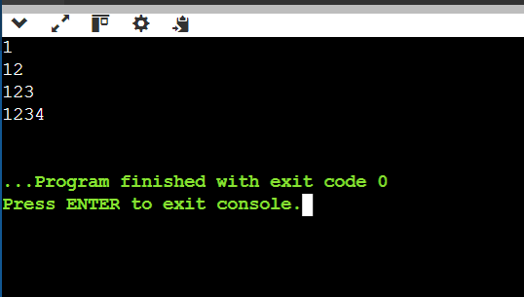

* **Question 2:**
* Source code:

#include <stdio.h>

int main()

{

int mat[2][2],i,j;

printf("Enter values of 2x2 matrix:\n ");

for(i=0;i<2;i++)

{

for (j=0;j<2;j++)

{

printf("value at index[%d][%d]: ",i,j);

scanf("%d",&mat[i][j]);

}

}

printf("transpose:\n");

for(i=0;i<2;i++)

{

for (j=0;j<2;j++)

printf("%d",mat[j][i]);

printf("\n");

}

}

* Output:

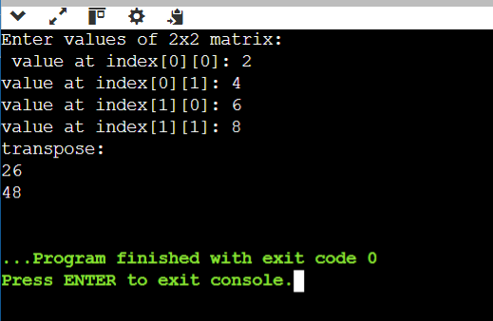

* **Question 3:**
* Source code:

#include <stdio.h>

int main()

{

int mat[2][3][3]={

{{1,2,3},{4,5,6},{7,8,9}},

{{11,12,13},{14,15,16},{17,18,19}}

},i,j,k,sum1=0,sum2=0;

for (i=0;i<3;i++)

{

for (j=0;j<3;j++)

sum1=sum1+mat[0][i][j];

}

for (i=0;i<3;i++)

{

for (j=0;j<3;j++)

sum2=sum2+mat[1][i][j];

}

printf("Sum of first page elements is: %d\n",sum1);

printf("Sum of second page elements is: %d\n",sum2);

}

* Output:

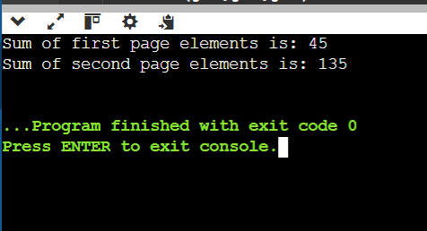

* **Question 4:**

#include <stdio.h>

int main()

{

int n, i, j, d;

printf("Enter the range for prime numbers: ");

scanf("%d", &n);

for (i = 2; i <= n; i++)

{

d = 1;

for (j = 2; j < i; j++)

{

if (i % j == 0)

{

d = 0;

break;

}

}

if (d == 1)

printf("%d ", i);

}

printf("\n");

return 0;

}

* Output:

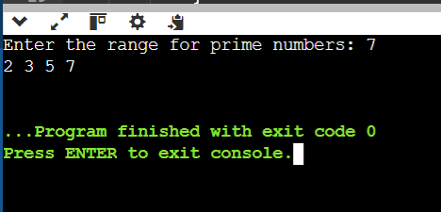

* **Question 5:**
* Source code:

#include <stdio.h>

int main()

{

int n,i,j;

printf("Enter range of odd numbers: ");

scanf("%d",&n);

for (i = n; i >= 1; i -= 2)

{

for (j = i; j >= 1; j -= 2)

{

printf("%d ", j);

}

printf("\n");

}

}

* Output:

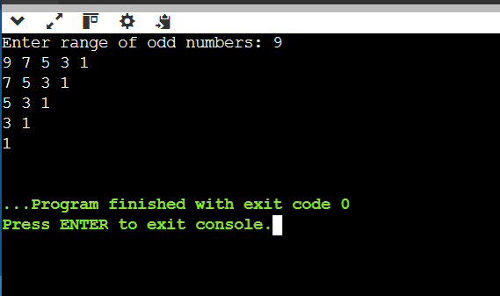

* **Question 6:**
* Source code:

#include <stdio.h>

int main() {

int i, j, min, index, max;

int a[3][3] = {{1, 2, 3}, {3, 4, 5}, {6, 7, 8}};

int saddle = 0;

for (i = 0; i < 3; i++) {

min = a[i][0];

index = 0;

for (j = 1; j < 3; j++)

{

if (a[i][j] < min)

{

min = a[i][j];

index = j;

}

}

max = 1;

for (j = 0; j < 3; j++) {

if (a[j][index] > min) {

max = 0;

break;

}

}

if (max==1) {

printf("Saddle point is %d at [%d][%d]\n", min, i, index);

saddle = 1;

}

}

if (saddle==0) {

printf("No saddle point\n");

}

return 0;

}

* Output:

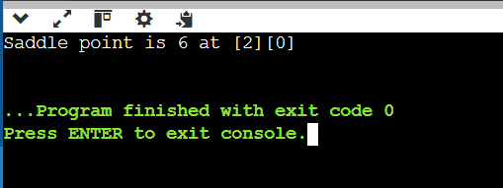

* **Question 7:**
* Source code:

#include <stdio.h>

int main()

{

int mat1[3][3],mat2[3][3],r[3][3],i,j,k,sum;

printf("Enter elements of 3x3 matrix1:\n");

for (i=0;i<3;i++)

{

for (j=0;j<3;j++)

{

printf("value at [%d][%d]: ", i,j);

scanf("%d",&mat1[i][j]);

}

}

printf("Enter elements of 3x3 matrix2:\n");

for (i=0;i<3;i++)

{

for (j=0;j<3;j++)

{

printf("value at [%d][%d]: ", i,j);

scanf("%d",&mat2[i][j]);

}

}

for (i=0;i<3;i++)

{

for (j=0;j<3;j++)

{

sum=0;

for (k=0;k<3;k++)

sum = sum + (mat1[i][k] * mat2[k][j]);

r[i][j]=sum;

printf("%d ",r[i][j]);

}

printf("\n");

}

return 0;

}

* Output:

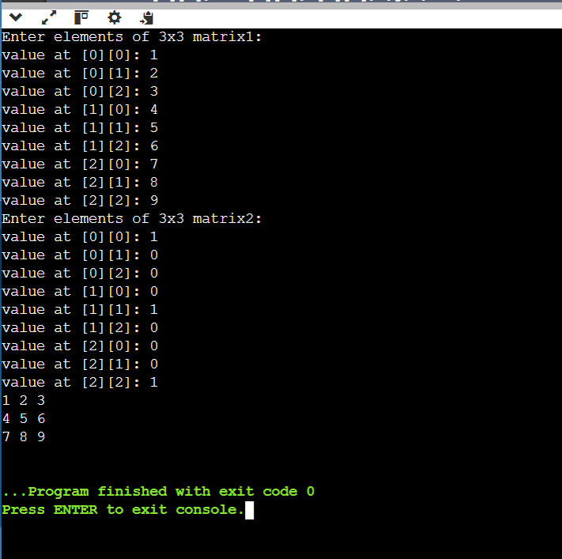

* **Question 8:**
* Source code:

#include <stdio.h>

int main() {

int n, i, j;

printf("Enter number of rows for the upper half: ");

scanf("%d", &n);

for (i = 1; i <= n+1; i++) {

for (j = 1; j <= n - i+1; j++) {

printf(" ");

}

for (j = 1; j <= i; j++) {

printf("* ");

}

printf("\n");

}

for (i = n ; i >= 1; i--) {

for (j = 1; j <= n -i+1; j++) {

printf(" ");

}

for (j = 1; j <= i; j++) {

printf("* ");

}

printf("\n");

}

return 0;

}

* Output:

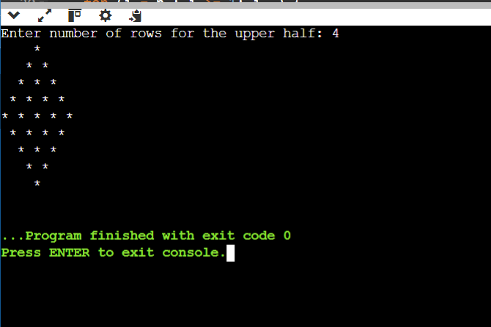

**Extra questions**

* **Question 1:**
* Source code:

#include <stdio.h>

int main()

{

int i,j,n;

printf("enter number of times to print: ");

scanf("%d",&n);

for (i=n;i>0;i--)

{

for(j=1;j<=i;j++)

printf("%d",j);

printf("\n");

}

return 0;

}

* Output:

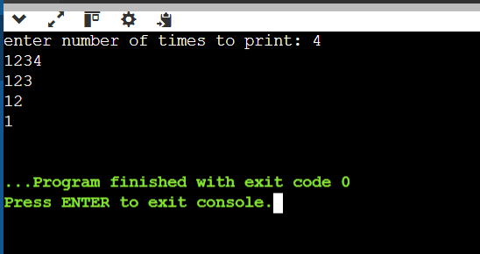

* **Question 2:**
* Source code:

#include <stdio.h>

int main()

{

int i,j,k;

for(i=1;i<=5;i++)

{

for (k=1;k<i;k++)

printf(" ");

for (j=6-i;j>0;j--)

printf("*");

printf("\n");

}

}

* Output:

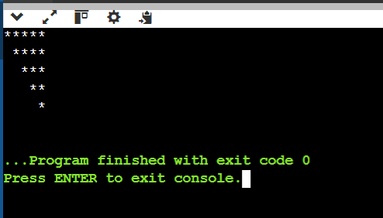

* **Question 3:**
* Source code:

#include <stdio.h>

int main()

{

int mat[3][3],i,j;

printf("Enter elements of a 3x3 matrix:\n");

for (i=0;i<3;i++)

{

for (j=0;j<3;j++)

{

printf("value at [%d][%d]: ", i,j);

scanf("%d",&mat[i][j]);

}

}

printf("reverse elements are:\n");

for (i=0;i<3;i++)

{

for (j=2;j>=0;j--)

printf("%d",mat[i][j]);

printf("\n");

}

return 0;

}

* Output:

